# Github intergrate + Maven build

Go to repo setting - webhooks:

[https://github.com/<account>/<repo>/settings/hooks](https://github.com/%3caccount%3e/%3crepo%3e/settings/hooks)

choose setting below:

|  |
| --- |
| payload url: your url  Content type: application/json  if your url is https, choose enable ssl |

Add webhook

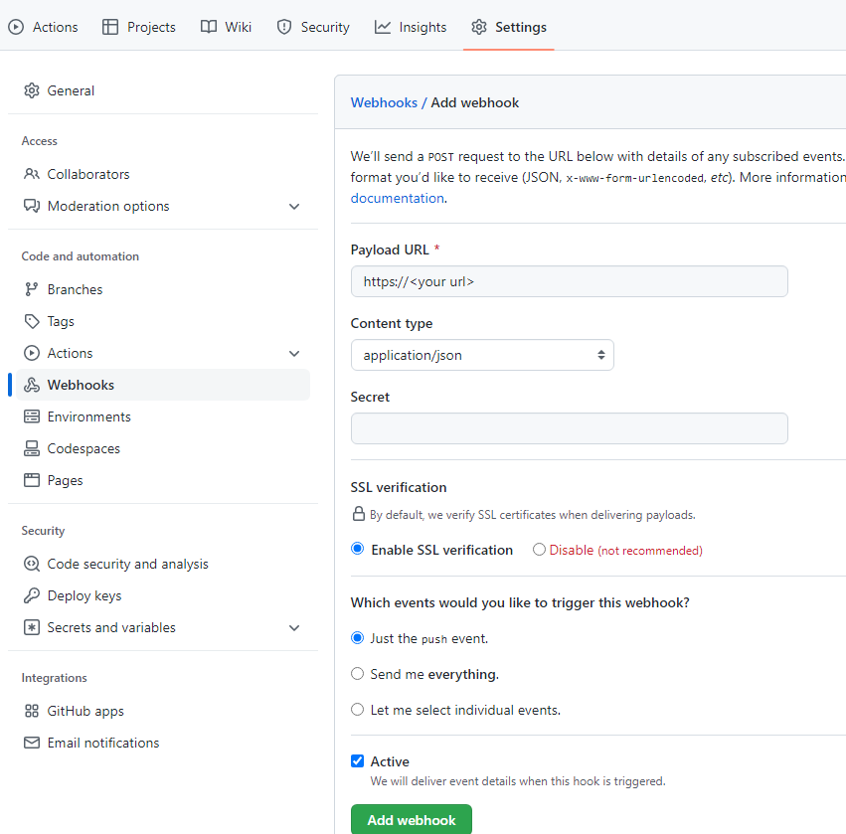

Create new pipeline and check "GitHub hook trigger for GITScm polling" it will trigger git and automate build and trigger jenkins .

Dashboard 
devsecops-app-num 
Configure 
General 
Advanced Project Options 
Pipeline 
Configuration 
General 
Description 
[Plain text] Preview 
Discard old builds ? 
Do not allow concurrent builds 
o 
Do not allow the pipeline to resume if the controller restarts 
o 
GitHub project 
o 
Pipeline speed/durability override ? 
o 
Preserve stashes from completed builds 
o 
This project is parameterized ? 
Throttle bu ilds ? 
Build Triggers 
o 
Build after other projects are built 
o 
Build periodically ? 
GitHub hook trigger for GITScm polling 
Enabled 

Scrolldown and type your repo and branch. apply and build

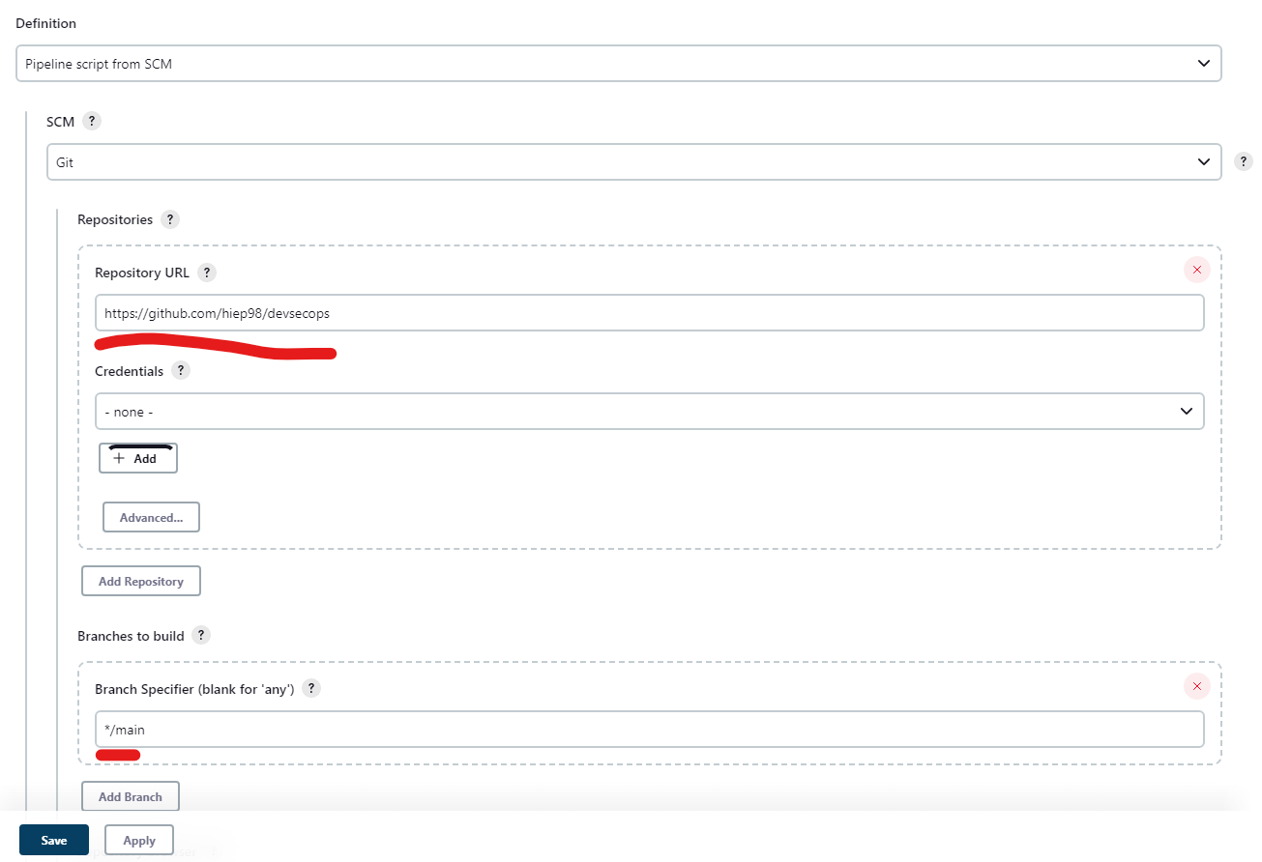

When you update code in git, git will call jenkins whenever a push event has been done.

We have file source code below:

|  |
| --- |
| pipeline {    agent any    stages {        stage('Build Artifact') {              steps {                sh "mvn clean package -DskipTests=true"                archive 'target/*.jar' *//so that they can be downloaded later*              }          }      }  } |

The Jenkins pipeline above is designed to create an artifact, or executable, in this case a *.jar file. First, it will run a command to execute the **`mvn clean package -DskipTests=true`** command, which cleans and packages the code. Then, it will store the built *.jar files in the **`target`** directory and archive them using the **`archive 'target/*.jar'`** command. This makes the files easier to share with other users and keeps them safe from accidental changes.